Lab - Configure and Verify Extended IPv4 ACLs

Topology
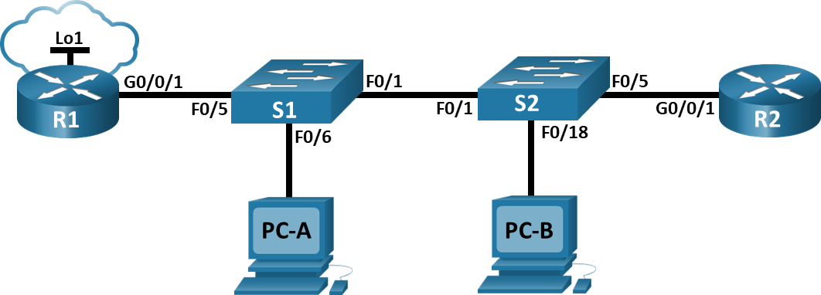

Addressing Table
Device | Interface | IP Address | Subnet Mask | Default Gateway
R1 | G0/0/1 | N/A | N/A | N/A
R1 | G0/0/1.20 | 10.20.0.1 | 255.255.255.0 | N/A
R1 | G0/0/1.30 | 10.30.0.1 | 255.255.255.0 | N/A
R1 | G0/0/1.40 | 10.40.0.1 | 255.255.255.0 | N/A
R1 | G0/0/1.1000 | N/A | N/A | N/A
R1 | Loopback1 | 172.16.1.1 | 255.255.255.0 | N/A
R2 | G0/0/1 | 10.20.0.4 | 255.255.255.0 | N/A
S1 | VLAN 20 | 10.20.0.2 | 255.255.255.0 | 10.20.0.1
S2 | VLAN 20 | 10.20.0.3 | 255.255.255.0 | 10.20.0.1
PC-A | NIC | 10.30.0.10 | 255.255.255.0 | 10.30.0.1
PC-B | NIC | 10.40.0.10 | 255.255.255.0 | 10.40.0.1

VLAN Table
VLAN | Name | Interface Assigned
20 | Management | S2: F0/5
30 | Operations | S1: F0/6
40 | Sales | S2: F0/18
999 | ParkingLot | S1: F0/2-4, F0/7-24, G0/1-2  S2: F0/2-4, F0/6-17, F0/19-24, G0/1-2
1000 | Native | N/A

Objectives
Part 1: Build the Network and Configure Basic Device Settings
Part 2: Configure and Verify Extended Access Control Lists

Background / Scenario
You have been tasked with configuring access control lists on small company’s network. ACLs are one of the simplest and most direct means of controlling layer 3 traffic. R1 will be hosting an internet connection (simulated by interface Loopback 1) and sharing the default route information to R2. After initial configuration is complete, the company has some specific traffic security requirements that you are responsible for implementing.
Note: The routers used with CCNA hands-on labs are Cisco 4221 with Cisco IOS XE Release 16.9.4 (universalk9 image). The switches used in the labs are Cisco Catalyst 2960s with Cisco IOS Release 15.2(2) (lanbasek9 image). Other routers, switches, and Cisco IOS versions can be used. Depending on the model and Cisco IOS version, the commands available and the output produced might vary from what is shown in the labs. Refer to the Router Interface Summary Table at the end of the lab for the correct interface identifiers.
Note: Ensure that the routers and switches have been erased and have no startup configurations. If you are unsure contact your instructor.

Required Resources
- 2 Routers (Cisco 4221 with Cisco IOS XE Release 16.9.4 universal image or comparable)
- 2 Switches (Cisco 2960 with Cisco IOS Release 15.2(2) lanbasek9 image or comparable)
- 2 PCs (Windows with a terminal emulation program, such as Tera Term)
- Console cables to configure the Cisco IOS devices via the console ports
- Ethernet cables as shown in the topology

Instructions

Build the Network and Configure Basic Device Settings.

Cable the network as shown in the topology.
Attach the devices as shown in the topology diagram, and cable as necessary.

Configure basic settings for each router.
Open configuration window
      - Assign a device name to the router.
      - Disable DNS lookup to prevent the router from attempting to translate incorrectly entered commands as though they were host names.
      - Assign class as the privileged EXEC encrypted password.
      - Assign cisco as the console password and enable login.
      - Assign cisco as the VTY password and enable login.
      - Encrypt the plaintext passwords.
      - Create a banner that warns anyone accessing the device that unauthorized access is prohibited.
      - Save the running configuration to the startup configuration file.
Close configuration window

Configure basic settings for each switch.
Open configuration window
      - Assign a device name to the switch.
hostname S1
hostname S2
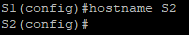
      - Disable DNS lookup to prevent the router from attempting to translate incorrectly entered commands as though they were host names.
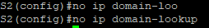
      - Assign class as the privileged EXEC encrypted password.
      - Assign cisco as the console password and enable login.
      - Assign cisco as the VTY password and enable login.
      - Encrypt the plaintext passwords.
      - Create a banner that warns anyone accessing the device that unauthorized access is prohibited.
      - Save the running configuration to the startup configuration file.
copy run strart
Close configuration window

Configure VLANs on the Switches

Create VLANs on both switches.
Open configuration window
      - Create and name the required VLANs on each switch from the table above.
vlan 20
name Management

vlan 30
name Operations

int f0/5
sw m a
sw a vl 30
      - Configure the management interface and default gateway on each switch using the IP address information in the Addressing Table.
S2:
vlan 20
name Management

vlan 30
name Operations

vlan 40
name Sales

int vlan 20
ip address 10.20.0.3 255.255.255.0
ex
ip default-gateway 10.20.0.1
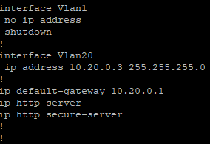
      - Assign all unused ports on the switch to the Parking Lot VLAN, configure them for static access mode, and administratively deactivate them.
Note: The interface range command is helpful to accomplish this task with as few commands as necessary.

Assign VLANs to the correct switch interfaces.
      - Assign used ports to the appropriate VLAN (specified in the VLAN table above) and configure them for static access mode.
int f0/5
sw m a
sw a vl 30

int f0/18
sw m a
sw a vl 40
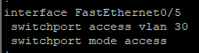
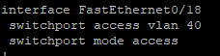
      - Issue the show vlan brief command and verify that the VLANs are assigned to the correct interfaces.
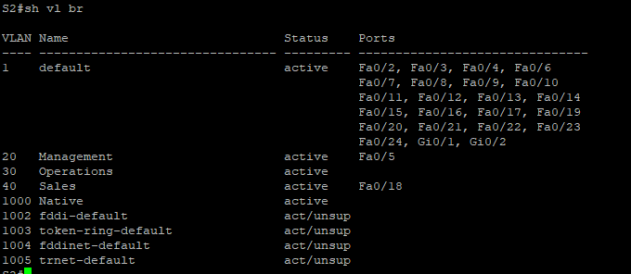

Close configuration window

Configure Trunking

Manually configure trunk interface F0/1.
Open configuration window
      - Change the switchport mode on interface F0/1 to force trunking. Make sure to do this on both switches.
int f0/1
sw m t
      - As a part of the trunk configuration, set the native vlan to 1000 on both switches. You may see error messages temporarily while the two interfaces are configured for different native VLANs.
sw t native vl 1000
      - As another part of trunk configuration, specify that VLANs 10, 20, 30, and 1000 are allowed to cross the trunk.
sw t all vl 10,20,30,1000
      - Issue the show interfaces trunk command to verify trunking ports, the Native VLAN and allowed VLANs across the trunk.
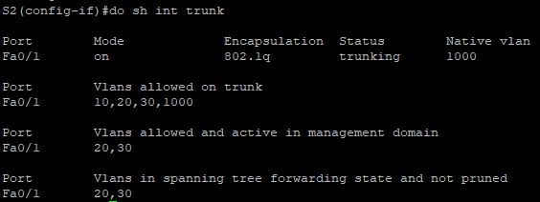

Manually configure S1’s trunk interface F0/5.
      - Configure S1’s interface F0/5 with the same trunk parameters as F0/1. This is the trunk to the router.
int f0/5
sw m t
sw t na vl 1000
sw t all vl 10,20,30,1000
      - Save the running configuration to the startup configuration file.
copy run st
      - Issue the show interfaces trunk command to verify trunking.
Close configuration window

Configure Routing

Configure Inter-VLAN Routing on R1.
Open configuration window
      - Activate interface G0/0/1 on the router.
int g0/0/1
no shut

      - Configure sub-interfaces for each VLAN as specified in the IP addressing table. All sub-interfaces use 802.1Q encapsulation. Ensure the sub-interface for the native VLAN does not have an IP address assigned. Include a description for each sub-interface.
int g0/0/1.20
encapsulation dot1q 20
ip add 10.20.0.1 255.255.255.0
no shut

int g0/0/1.30
encapsulation dot1q 30
ip add 10.30.0.1 255.255.255.0
no shut

int g0/0/1.40
encapsulation dot1q 40
ip add 10.40.0.1 255.255.255.0
no shut

int g0/0/1.1000
encapsulation dot1q 1000
no shut
      - Configure interface Loopback 1 on R1 with addressing from the table above.
int Loopback1
ip add 172.16.1.1 255.255.255.0
no shut
      - Use the show ip interface brief command to verify the sub-interfaces are operational.
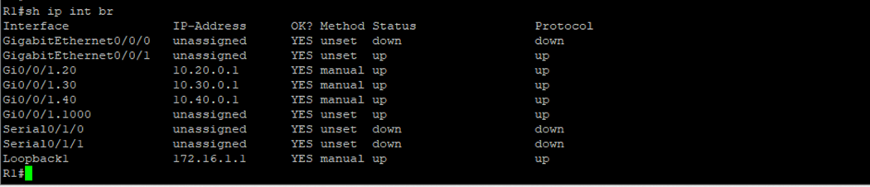

Configure the R2 interface g0/0/1 using the address from the table and a default route with the next hop 10.20.0.1
int g0/0/1
ip add 10.20.0.4 255.255.255.0
no shut

ip route 0.0.0.0 0.0.0.0 10.20.0.1
Close configuration window

Configure Remote Access

Configure all network devices for basic SSH support.
Open configuration window
      - Create a local user with the username SSHadmin and the encrypted password $cisco123!
username SSHadmin secret $cisco123!
      - Use ccna-lab.com as the domain name.
ip domain name ccna-lab.com
      - Generate crypto keys using a 1024-bit modulus.
crypto key generate rsa general-keys modulus 1024
      - Configure the first five VTY lines on each device to support SSH connections only and to authenticate to the local user database.
line vty 0 4
transport input ssh
login local

Enable secure, authenticated web services on R1.
      - Enable the HTTPS server on R1.
R1(config)# ip http secure-server
      - Configure R1 to authenticate users attempting to connect to the web server.
R1(config)# ip http authentication local
Close configuration window

Verify Connectivity

Configure PC hosts.
Refer to the Addressing Table for PC host address information.

Complete the following tests. All should be successful.
Note: You may have to disable the PC firewall for pings to be successful.
From | Protocol | Destination
PC-A | Ping | 10.40.0.10
PC-A | Ping | 10.20.0.1
PC-B | Ping | 10.30.0.10
PC-B | Ping | 10.20.0.1
PC-B | Ping | 172.16.1.1
PC-B | HTTPS | 10.20.0.1
PC-B | HTTPS | 172.16.1.1
PC-B | SSH | 10.20.0.1
PC-B | SSH | 172.16.1.1

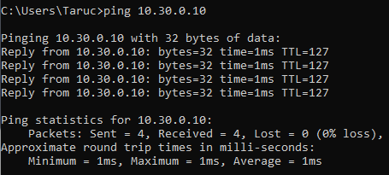
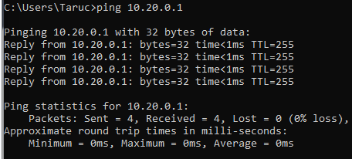
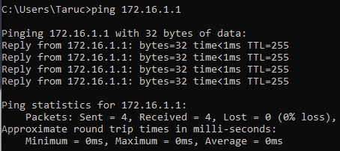

Configure and Verify Extended Access Control Lists.
When basic connectivity is verified, the company requires the following security policies to be implemented:
Policy 1: The Sales Network is not allowed to SSH to the Management Network (but other SSH is allowed).
Policy 2: The Sales Network is not allowed to access IP addresses in the Management network using any web protocol (HTTP/HTTPS). The Sales Network is also not allowed to access R1 interfaces using any web protocol. All other web traffic is allowed (note – Sales can access the Loopback 1 interface on R1).
Policy 3: The Sales Network is not allowed to send ICMP echo-requests to the Operations or Management Networks. ICMP echo requests to other destinations are allowed.
Policy 4: The Operations network is not allowed to send ICMP echo-requests to the Sales network. ICMP echo requests to other destinations are allowed.
Source | Destination | Protocol eq x | Router
Sales Network (vlan 40) | Management Network (vlan 20) | tcp eq 22 | R1 G0/0/1.40
Sales Network (vlan 40) | Management Network (vlan 20) | tcp eq 80 | R1 G0/0/1.40
Sales Network | R1 host 10.20.0.1  R1 host 10.30.0.1  R1 host 10.40.0.1 | tcp eq 80  tcp eq 443 | R1 G0/0/1.40
Sales Network (vlan 40) | Operation (vlan 30)  Management (vlan 20) | icmp | R1 G0/0/1.40
Operation Network (vlan 30) | Sales Network (vlan 40) | icmp | R1 G0/0/1.30
R1 G0/0/1.40:

access-list 110 tcp 10.40.0.0

access-list 110 deny tcp 10.40.0.0 0.0.0.255 10.20.0.0 0.0.0.255 eq 22
access-list 110 deny tcp 10.40.0.0 0.0.0.255 10.20.0.0 0.0.0.255 eq 80
access-list 110 deny tcp 10.40.0.0 0.0.0.255 10.20.0.0 0.0.0.255 eq 443
access-list 110 permit tcp 10.40.0.0 0.0.0.255 172.16.1.1 0.0.0.0 eq 80
access-list 110 permit tcp 10.40.0.0 0.0.0.255 172.16.1.1 0.0.0.0 eq 443
access-list 110 deny icmp 10.40.0.0 0.0.0.255 10.30.0.0 0.0.0.255 echo
access-list 110 deny icmp 10.40.0.0 0.0.0.255 10.20.0.0 0.0.0.255 echo
access-list 110 permit ip any any
int g0/0/1.40
ip access-group 110 in

access-list 120 deny icmp 10.30.0.0 0.0.0.255 10.40.0.0 0.0.0.255 echo
access-list 120 permit ip any any
int g0/0/1.30
ip access-group 120 in

Analyze the network and the security policy requirements to plan ACL implementation.

Develop and apply extended access lists that will meet the security policy statements.

Verify security policies are being enforced by the deployed access lists.
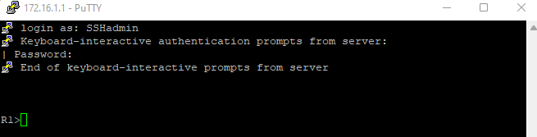
Run the following tests. The expected results are shown in the table:
From | Protocol | Destination | Result
PC-A | Ping | 10.40.0.10 | Fail
PC-A | Ping | 10.20.0.1 | Success
PC-B | Ping | 10.30.0.10 | Fail
PC-B | Ping | 10.20.0.1 | Fail
PC-B | Ping | 172.16.1.1 | Success
PC-B | HTTPS | 10.20.0.1 | Fail
PC-B | HTTPS | 172.16.1.1 | Success
PC-B | SSH | 10.20.0.4 | Fail
PC-B | SSH | 172.16.1.1 | Success

End of document

